Visual Arts/Comprehensive I
Pickens High School

Mrs. Nikki Towery nikkitowery@pickenscountyschools.org

This course will introduce students to a variety of drawing mediums (graphite pencils, colored pencils, charcoal, pen and ink) and paints (acrylic, tempera, watercolor) used on different papers and materials for various 2-dimensional art assignments. Clay, sculpture, and collage will be introduced for 3-dimensional projects. This class will involve demonstrations, studio experiences, tests and quizzes, sketchbook assignments, and a final exam/project.

All projects and assignments will relate to the Art Elements and Principles of Design. Through the study of artists and artwork from various periods in history, students broaden their cultural awareness. Students will become familiar with specific artists and their impact on the world.

Materials Needed: See Supply List

Grading Formula: Formative Grades (80% of total grade)
Daily Grade (participation/work ethic): 20%
Studio Projects: 40%
Sketchbook / Homework: 10%
Quizzes / Written Assignments 10%

Summative Grades (20 % of total grade)

Semester Project / Exam 20%

Classroom Expectations:

In addition to this syllabus, students will follow all rules and regulations set forth in the 2017-2018 PHS Handbook. All school rules apply in this classroom; refer to your handbook for more details.

- Show a willingness to participate and try ones best.
- Hand in completed assignments on time. It is the student’s responsibility to turn in work in the designated area. Work that is not turned in to the proper area will not be graded. After an absence, students must ask teacher for missing assignments.
- Treat classroom supplies with respect and care.
- Clean up at the appropriate time – Not too early or too late. Do not leave supplies or work out on the tables or in an undesignated area. Brushes and palettes must be cleaned before students are allowed to leave the classroom.
- No cell phone use during class (unless specified by the teacher). Cell phone use at an unspecified time or for a nonacademic activity will result in the phone being taken up until the end of class. A second offense will result in an office referral.
- No food or canned drinks are allowed. Water or soda in a closed container is acceptable.
- Treat everyone, as you would wish to be treated; be kind and mature.
- All students are expected to be in the art room when the tardy bell rings. The school tardy policy will be followed.
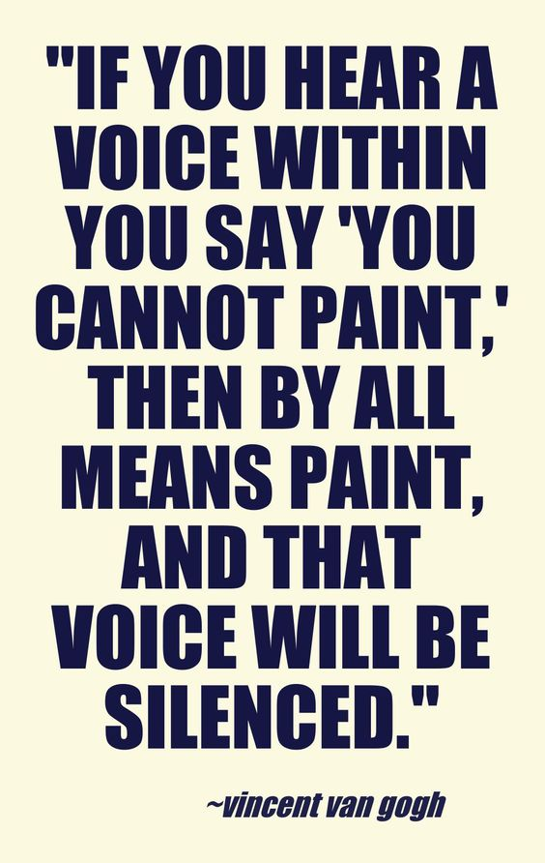

Visual Arts/Comprehensive I
Parent/Guardian/Student Contract

I have read and understand the syllabus and guidelines for this class.

Please return this form to Mrs. Towery by: Monday, August 7, 2017

Student Signature Parent/Guardian Signature

Comments:

Parent/Guardian Home or Cell Phone Parent/Guardian Email Address

Visual Arts/Comprehensive I
Classroom Responsibilities of the Student
*It is my responsibility to:

1. Bring required materials to class daily.
2. Be responsible for my attendance in class.
3. Be on time.
4. Adhere to school dress code and school guidelines as
outlined in the PHS Handbook.
5. Not bring food/candy/gum or drink into the art room areas.
6. Work to the best of my ability every day.
7. Complete make-up work within allotted time.
8. Be alert in class and not sleep during class.
9. Be an active participant in art class with a positive attitude.

Student Signature Date

